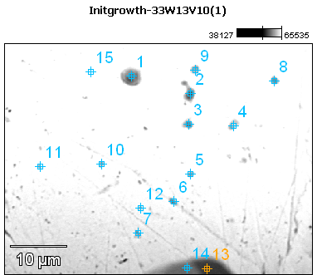

Image Name: Initgrowth-33W13V10(1)

Image Resolution: 512 by 384

Image Pixel Size: 0.11 µm

Acc. Voltage: 13.0 kV

Magnification: 2300

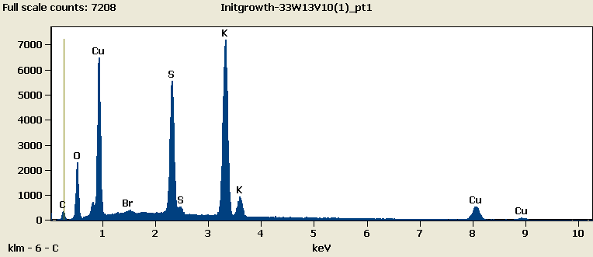

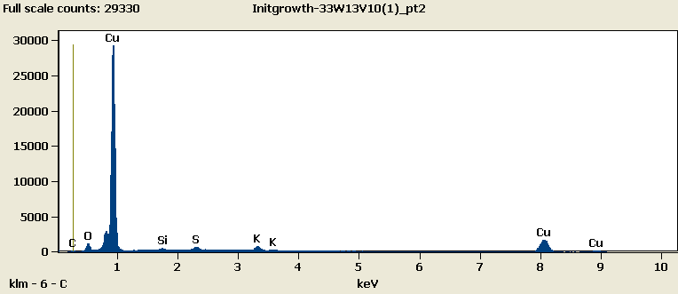

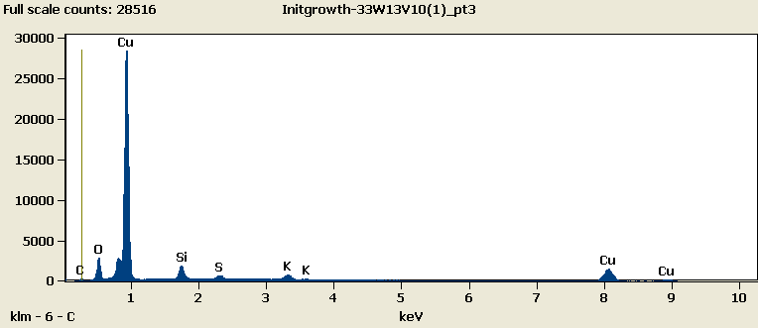

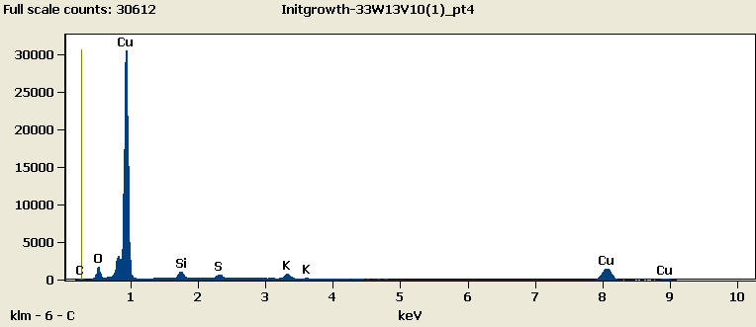

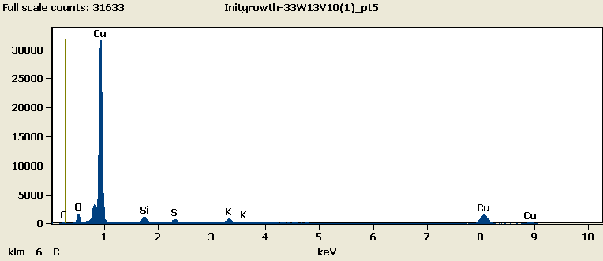

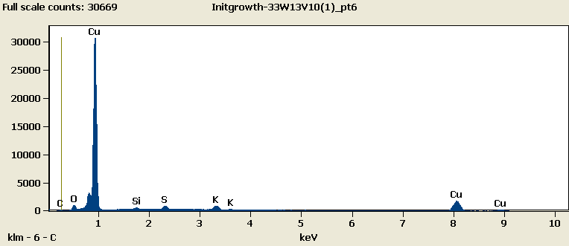

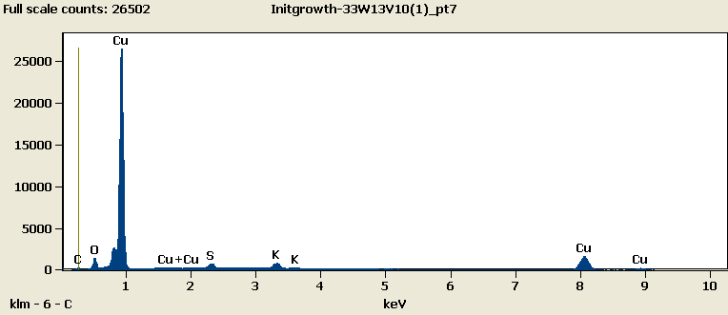

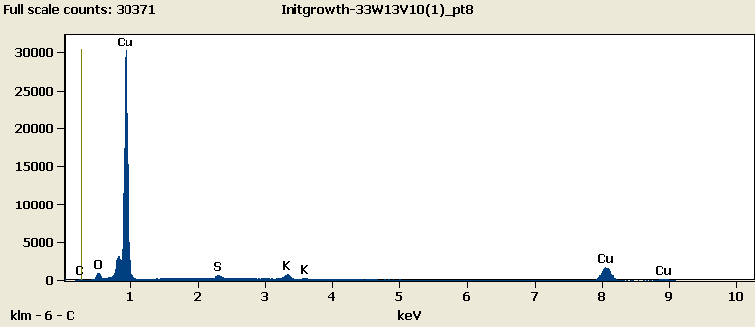

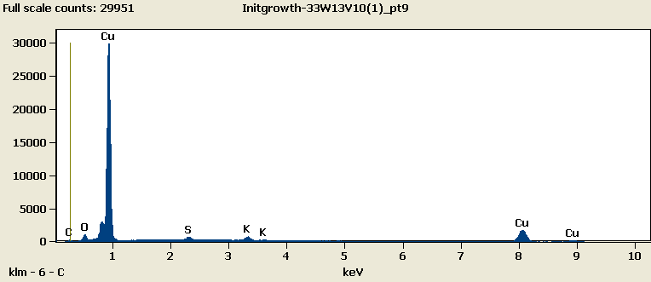

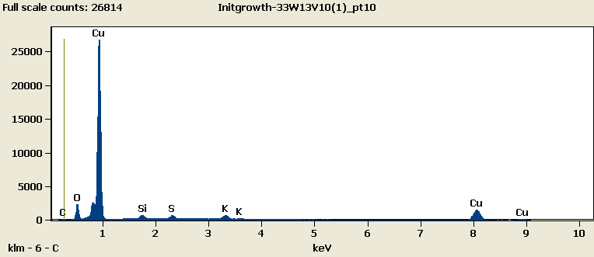

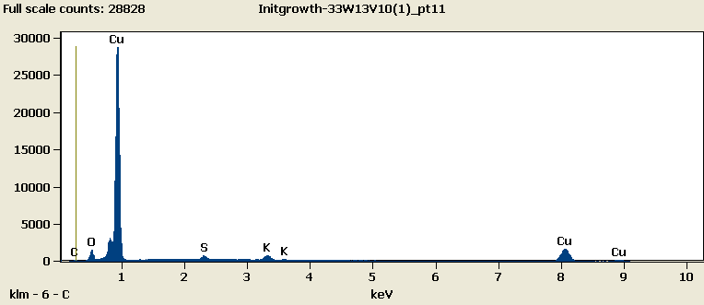

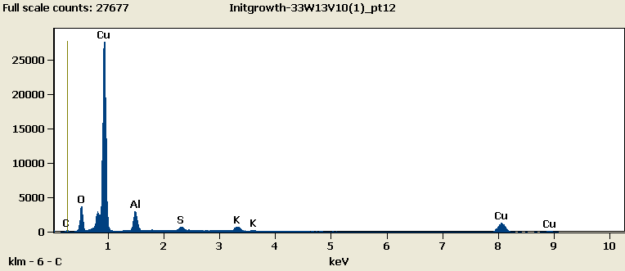

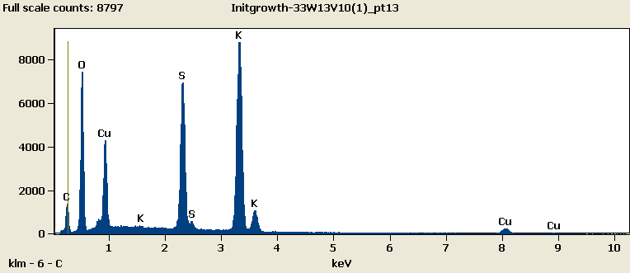

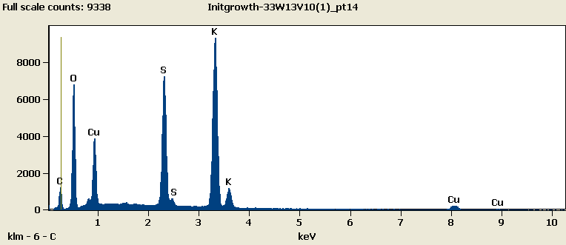

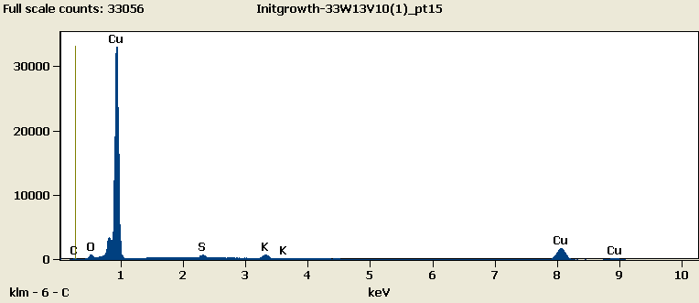

Weight %

|  |  |  |  |  |  |  |  |  |
| --- | --- | --- | --- | --- | --- | --- | --- | --- |
|  | ***C-K*** | ***O-K*** | ***Al-K*** | ***Si-K*** | ***S-K*** | ***K-K*** | ***Cu-L*** | ***Br-L*** |
| ***Initgrowth-33W13V10(1)_pt1*** | 4.22 | 12.72 |  |  | 16.62 | 33.41 | 32.45 | 0.58 |
| ***Initgrowth-33W13V10(1)_pt2*** | 2.76 | 3.70 |  | 0.41 | 1.15 | 2.07 | 89.91 |  |
| ***Initgrowth-33W13V10(1)_pt3*** | 2.38 | 6.99 |  | 3.52 | 1.22 | 2.05 | 83.84 |  |
| ***Initgrowth-33W13V10(1)_pt4*** | 2.79 | 4.33 |  | 1.96 | 1.26 | 2.15 | 87.51 |  |
| ***Initgrowth-33W13V10(1)_pt5*** | 2.94 | 4.31 |  | 1.99 | 1.22 | 2.10 | 87.45 |  |
| ***Initgrowth-33W13V10(1)_pt6*** | 2.93 | 2.95 |  | 0.64 | 1.51 | 2.70 | 89.28 |  |
| ***Initgrowth-33W13V10(1)_pt7*** | 2.48 | 4.42 |  |  | 1.72 | 2.94 | 88.44 |  |
| ***Initgrowth-33W13V10(1)_pt8*** | 2.81 | 2.95 |  |  | 1.22 | 2.12 | 90.90 |  |
| ***Initgrowth-33W13V10(1)_pt9*** | 2.88 | 3.22 |  |  | 1.17 | 2.01 | 90.72 |  |
| ***Initgrowth-33W13V10(1)_pt10*** | 2.42 | 6.32 |  | 1.35 | 1.31 | 2.05 | 86.54 |  |
| ***Initgrowth-33W13V10(1)_pt11*** | 2.57 | 3.98 |  |  | 1.16 | 2.18 | 90.10 |  |
| ***Initgrowth-33W13V10(1)_pt12*** | 2.58 | 8.56 | 6.10 |  | 1.24 | 2.22 | 79.30 |  |
| ***Initgrowth-33W13V10(1)_pt13*** | 8.73 | 28.45 |  |  | 15.27 | 30.56 | 16.98 |  |
| ***Initgrowth-33W13V10(1)_pt14*** | 8.09 | 28.16 |  |  | 15.81 | 32.16 | 15.78 |  |
| ***Initgrowth-33W13V10(1)_pt15*** | 3.01 | 1.98 |  |  | 1.13 | 1.82 | 92.06 |  |

Weight % Error (+/- 1 Sigma)

|  |  |  |  |  |  |  |  |  |
| --- | --- | --- | --- | --- | --- | --- | --- | --- |
|  | ***C-K*** | ***O-K*** | ***Al-K*** | ***Si-K*** | ***S-K*** | ***K-K*** | ***Cu-L*** | ***Br-L*** |
| ***Initgrowth-33W13V10(1)_pt1*** | ±0.17 | ±0.17 |  |  | ±0.12 | ±0.20 | ±0.21 | ±0.07 |
| ***Initgrowth-33W13V10(1)_pt2*** | ±0.16 | ±0.08 |  | ±0.06 | ±0.07 | ±0.10 | ±0.32 |  |
| ***Initgrowth-33W13V10(1)_pt3*** | ±0.15 | ±0.09 |  | ±0.06 | ±0.07 | ±0.09 | ±0.30 |  |
| ***Initgrowth-33W13V10(1)_pt4*** | ±0.15 | ±0.08 |  | ±0.06 | ±0.07 | ±0.09 | ±0.30 |  |
| ***Initgrowth-33W13V10(1)_pt5*** | ±0.15 | ±0.08 |  | ±0.06 | ±0.07 | ±0.09 | ±0.30 |  |
| ***Initgrowth-33W13V10(1)_pt6*** | ±0.15 | ±0.08 |  | ±0.05 | ±0.07 | ±0.09 | ±0.31 |  |
| ***Initgrowth-33W13V10(1)_pt7*** | ±0.16 | ±0.09 |  |  | ±0.08 | ±0.10 | ±0.31 |  |
| ***Initgrowth-33W13V10(1)_pt8*** | ±0.16 | ±0.08 |  |  | ±0.07 | ±0.09 | ±0.32 |  |
| ***Initgrowth-33W13V10(1)_pt9*** | ±0.16 | ±0.08 |  |  | ±0.07 | ±0.10 | ±0.32 |  |
| ***Initgrowth-33W13V10(1)_pt10*** | ±0.16 | ±0.09 |  | ±0.06 | ±0.07 | ±0.10 | ±0.31 |  |
| ***Initgrowth-33W13V10(1)_pt11*** | ±0.15 | ±0.08 |  |  | ±0.07 | ±0.09 | ±0.31 |  |
| ***Initgrowth-33W13V10(1)_pt12*** | ±0.16 | ±0.09 | ±0.07 |  | ±0.06 | ±0.08 | ±0.28 |  |
| ***Initgrowth-33W13V10(1)_pt13*** | ±0.19 | ±0.20 |  |  | ±0.09 | ±0.16 | ±0.16 |  |
| ***Initgrowth-33W13V10(1)_pt14*** | ±0.18 | ±0.20 |  |  | ±0.09 | ±0.17 | ±0.15 |  |
| ***Initgrowth-33W13V10(1)_pt15*** | ±0.15 | ±0.07 |  |  | ±0.07 | ±0.09 | ±0.31 |  |

# Cations

|  |  |  |  |  |  |  |  |  |
| --- | --- | --- | --- | --- | --- | --- | --- | --- |
|  | ***C-K*** | ***O-K*** | ***Al-K*** | ***Si-K*** | ***S-K*** | ***K-K*** | ***Cu-L*** | ***Br-L*** |
| ***Initgrowth-33W13V10(1)_pt1*** | 0.00 | 0.00 |  |  | 0.00 | 0.00 | 0.00 | 0.00 |
| ***Initgrowth-33W13V10(1)_pt2*** | 0.00 | 0.00 |  | 0.00 | 0.00 | 0.00 | 0.00 |  |
| ***Initgrowth-33W13V10(1)_pt3*** | 0.00 | 0.00 |  | 0.00 | 0.00 | 0.00 | 0.00 |  |
| ***Initgrowth-33W13V10(1)_pt4*** | 0.00 | 0.00 |  | 0.00 | 0.00 | 0.00 | 0.00 |  |
| ***Initgrowth-33W13V10(1)_pt5*** | 0.00 | 0.00 |  | 0.00 | 0.00 | 0.00 | 0.00 |  |
| ***Initgrowth-33W13V10(1)_pt6*** | 0.00 | 0.00 |  | 0.00 | 0.00 | 0.00 | 0.00 |  |
| ***Initgrowth-33W13V10(1)_pt7*** | 0.00 | 0.00 |  |  | 0.00 | 0.00 | 0.00 |  |
| ***Initgrowth-33W13V10(1)_pt8*** | 0.00 | 0.00 |  |  | 0.00 | 0.00 | 0.00 |  |
| ***Initgrowth-33W13V10(1)_pt9*** | 0.00 | 0.00 |  |  | 0.00 | 0.00 | 0.00 |  |
| ***Initgrowth-33W13V10(1)_pt10*** | 0.00 | 0.00 |  | 0.00 | 0.00 | 0.00 | 0.00 |  |
| ***Initgrowth-33W13V10(1)_pt11*** | 0.00 | 0.00 |  |  | 0.00 | 0.00 | 0.00 |  |
| ***Initgrowth-33W13V10(1)_pt12*** | 0.00 | 0.00 | 0.00 |  | 0.00 | 0.00 | 0.00 |  |
| ***Initgrowth-33W13V10(1)_pt13*** | 0.00 | 0.00 |  |  | 0.00 | 0.00 | 0.00 |  |
| ***Initgrowth-33W13V10(1)_pt14*** | 0.00 | 0.00 |  |  | 0.00 | 0.00 | 0.00 |  |
| ***Initgrowth-33W13V10(1)_pt15*** | 0.00 | 0.00 |  |  | 0.00 | 0.00 | 0.00 |  |